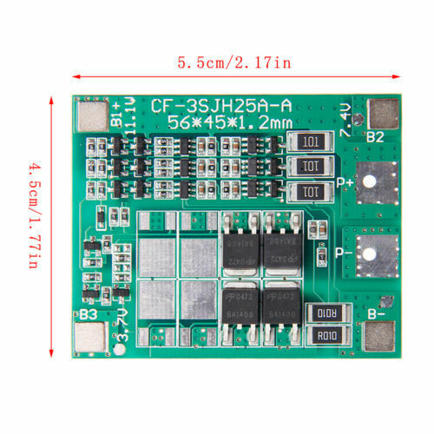
- 4S 14.8V 16.8V 20A
- Features:
1) high-accuracy voltage detection circuit;
2) terminal of the charger using high voltage device;
3) Built-in three-stage over-current detection circuit (over-current 1, over-current 2, or load short circuit);
4) MOS transistor can control the battery charge and discharge;
5) low standby current consumption
4 series 18650 battery 16.8V 16V 14.8V
14.8V (Li-ion 18650 or li-ion battery rated voltage)
16.8V (Li-ion battery full charge voltage)
14.4V ( Lipo battery pack rated voltage)
Applications:
4S Li-ion18650,LiCoO2,LiMn2O4,Li(NiCoMn)O2 rechargeable batteries
4S Lipo rechargeable batteries
BMS solder instruction:
B+ connected battery positive;
B1 the connect point between battery 1 and battery 2
B2 connect the point between battery2 and battery 3
B3 Connect the point between battery 3 and battery 4
B- connect to battery negative end
P- + connection charge / discharge positive;
P- connection charge / discharge negative
Note:
1) this board is not suit high power electronic tools, if use for screwdrier and drill, please don't buy
2)Above 3A device,means the battry discharge rate is more than 3C.
1C rated battery, 2000mah equals 2ah*1=2A max working current.
3C rated battery means 2ahx3=6A Max working current.
4S LI-ION BMS Specifications:
Over Charge Voltage:4.25-4.35v±0.05v
Over Discharge Voltage: 2.3-3.0v±0.05v
Max working current:10A
Max Peak current:20A
Working Temperature:-40~+50
Storage Temperature:-40~+80
Small current: 6uA
Life cycle:50000hours
Resistance:45mΩ
Short cut Protection:Protectable ,change for repair
Size: 3.6x3.5cm/1.42x1.38inch
Quantity: 1 Pc
Note:
The lithium battery protection board is not included the welding tabs.

