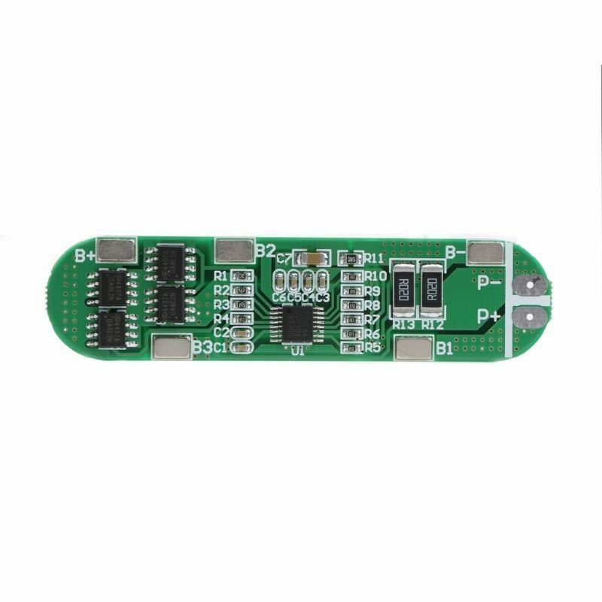
- 4S 16V 12A
- 4 series 18650 battery 16.8V 16V 14.8V
14.8V (Li-ion 18650 or li-ion battery rated voltage)
16.8V (Li-ion battery full charge voltage)
14.4V ( Lipo battery pack rated voltage)
The lithium battery protection board is not included the welding tabs.
Features:
1) high-accuracy voltage detection circuit;
2) terminal of the charger using high voltage device;
3) Built-in three-stage over-current detection circuit (over-current 1, over-current 2, or load short circuit);
4) MOS transistor can control the battery charge and discharge;
5) low standby current consumption.
P+/P- input/output interface, the same combination when the battery voltage, capacity, internal resistance should be matched well, combination without ouput, after the completion of voltage charging activation by 16.8V
Specifications:
Over Charge Voltage:4.25-4.35v±0.05v
Over Discharge Voltage: 2.3-3.0v±0.05v
Max Peak current: 6-8A
Max instantaneous current: 12A
Working Temperature: -40~+50℃
Storage Temperature:-40~+80℃
Static current: <30uA
Life cycle: >50000hours
Resistance: <100mΩ
Charging Voltage: 16.8-17V
Short cut Protection:Protectable ,change for repair
Size: 7.2x1.3cm/2.83x0.51inch
Quantity: 1 Pc

