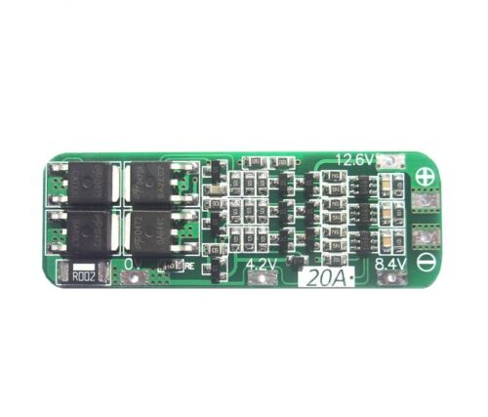
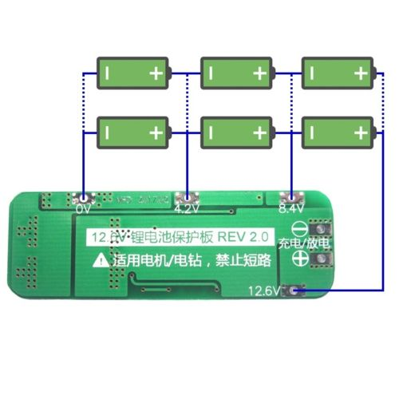
Features:
Module name: 3S 12.6V Li-ion Lithium Battery 18650 Charger Protection PCB Board
Suitable range: For nominal voltage 3.6V 3.7V lithium battery(Including 18650,26650, lithium polymer batteries)
Product Size: 64mmx20mmx3.4mm
Material:Metal
Charging voltage: 12.6V
Maximum output current: 20A
Maximum output power / charging power: 252W

