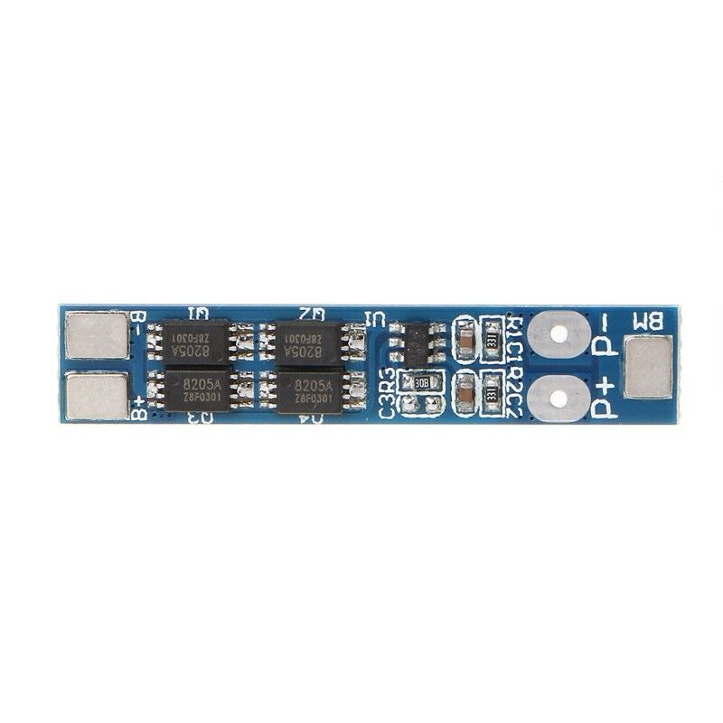

Charging voltage: 8.4V-9V
Overcharge voltage range: 4.28V±0.05V
Over discharge voltage range: 2.9V±0.05V
Upper limit working current: 8A
Upper limit instantaneous current: 16A
Working temperature: -40-+50℃
Storage conditions: -40-+80℃
Static electricity: less than 10 ua
Useful life: more than 30000 hours
Overcharge protection,over discharge protection,short circuit protection,over current protection
Size: 4.1x0.8cm/1.57x0.31inch

